
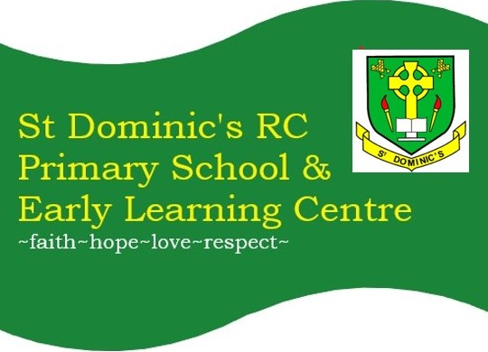
NEWSLETTER NO. 2025-26 – 22
st-dominics@pkc.gov.uk

CONTAINS:  - Sacraments  - ELC  - Bingo  - May Day Holiday  - Menu change  - Consent Forms  - Appeal  - Flyers  - Parent Council  - Next Week  - Dates  Wear PE KIT to school on your class PE day:  Monday: P6 & P4/5  Tuesday: P1/2 & P2/3  Thursday: P3/4, P6 & P7  Friday: P3/4, P4/5 & P7     | Dear Families,
 | Sacrament Confirmation: Thursday 07 May 2026 @ 6pm
 | We are looking forward to celebrating with our P7 Confirmandi on Thursday evening when they will be conferred the Sacrament of Confirmation by Bishop McKenzie in St Fillan’s Church.
 | ELC: Tuesday 05 May 2026 @ drop-off
 | On Tuesday morning Mrs Horan and myself Mrs Hunter are inviting all of our nursery parents to have a Partnership working discussion with us in the school hall at drop-off time. Please come have a tea/coffee and share some of your experiences of our improvements this session.
 | Bingo Tea: Friday 08 May 2026, Eyes down @ 6pm
 | One week to go! Please come and join in the family fun. Even if you have never played before, you'll quickly get the hang of it and will be shouting 'BINGO' before you know it. The purpose of this event is to raise funds for CHAS and for the school, to allow us to continue to subsidise opportunities for all our pupils. Payment by cash only, £1 per bingo book and raffle tickets £1 per strip.
 | May Day Holiday – Monday 4 May
 | Please note school, ELC and WAC are closed on Monday. We hope you enjoy the long weekend and look forward to welcoming you back on Tuesday 5 May.
 | Tayside Contracts Menu Change – Tuesday 5 May
 | Please note Tangy BBQ pizza slice is now being replaced with Quorn Dog roll with sweet chilli pasta, for both the Primary and ELC menus.
 | Consent Forms
 | This term is very busy with various opportunities and sometimes last minute offers; to help with planning we would be very grateful if responses/consents/forms could be completed by the due date.
 | Cardboard Appeal
 | Primary 3-4 are the class that will be making Roman shields over the next couple of weeks as part of this term's topic. If anyone has any large, flat pieces of cardboard, they would be very gratefully received to help the class with their project – please hand these into the school office.
 | Flyers: Please read what’s on in Strathearn’ email for flyers.
 | Parent Council: The next meeting is on 11 June @ 5:30pm, School Hall.
 | What’s on Next Week
Monday 4: (ELC & School closed): May Day Bank Holiday
Tuesday 5: 9am: ELC Partnership working P7 Swimming lessons 1130 – 1215, 3 of 10. H&W with Mrs Ogg: P1/2, P2/3 & P3/4 & Richmond House Singing Group 3pm.
Wednesday 6: Assembly AM. Rosary club with Mrs Dowell @ 3pm.
Thursday 7 May: P7 Sacrament of Confirmation, St Fillan's Parish @ 6pm - please wear school uniform. P4/5 Outdoor Learning (Groups A&B AM and Groups C&D PM). P6 Cricket lesson with Louis, session 1 of 2 @ 2-3pm.
Friday 8 May: Bingo Tea @ 6pm. H&W with Mrs Ogg: P4/5, P1/2 & Intervention groups. P4/5 & P6 attend Mass @ v St Fillan’s Parish. NHS Tayside Dental Check-up for P1 & P7 pupils.
Sunday 10 May: Primary 6 Mass
 | Important Term 4 Save the Dates
Tuesday 12 May: P3/4 Sharing the Learning Assembly, 9:30-10:30am
Wednesday 13 May: Shinty festival for St Dominic’s RCPS team & P1/2 Sharing the Learning Assembly, 2:45-3:15pm. New P1 August 2026 Welcome meeting @ 4:30pm.
Thursday 14 May @ 09:30am: Ascension of the Lord Mass, Parish
Wednesday 20 May: ELC Fun Day In (Show, Party & ELC Potted Sports) & P6 Sharing the Learning, 2:45-3:15pm
Thursday 21 May: P6 Cricket Festival @ Dallerie Playing Fields & P2/3 Sharing the Learning, 2:45-3:15pm
Monday 25 - Thursday 29 May: Healthy Hearts Week

Tuesday 26 May: Primary Sports Day
Wednesday 27 May: P4/5 Sharing the Learning, 2:45-3:15pm
Friday 29 May: INSET5 - ELC & School closed
Thursday 4 June: Education Mass @ St John the Baptist Church, Perth: (timings and invitation to follow)
Saturday 6 June: Sacrament of First Holy Communion, St Fillan's Parish @ 10am - Communion attire
Tuesday 16 June: Qualifiers Crieff Cluster County Sports @ George Duncan Arena Perth.

Sunday 21 June: Primary 5 Mass
Tuesday 23 June: Summer Concert - TBC
Tuesday 30 June: ELC & School Disco & Tayside BBQ Lunch, School Hall (3-3:30pm: ELC with Parent/Carer. 4-5pm: P1/2-P3/4, 5-6pm: P4/5-P7)
Thursday 2 July: Last Day of Term & End of Year Mass - End of Year Mass, School Hall @ 10:30am (families welcome, please be seated by 10:20am. ELC & School closes @ 12pm.Friday 3 July – Friday 14 August 2026: Summer Holidays
Monday 17 August 2026: INSET1 ELC & School closed
Tuesday 20 August 2026: ELC & School commences
Have a lovely weekend, Mrs E Hunter

