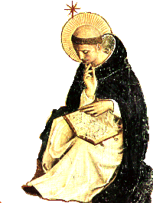

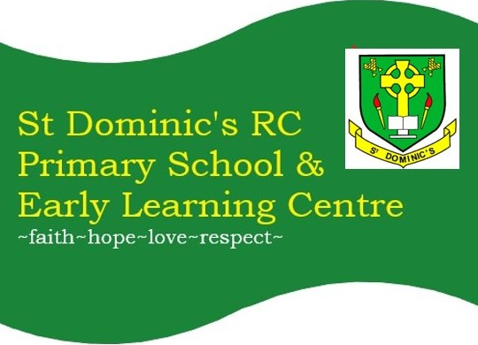
NEWSLETTER 02.10.26: 7
st-dominics@pkc.gov.uk

ESCONTAINS:  - Message  - Christmas  - Meet the Teacher/ELC  - Payments  - Reminders  - Parish  - Flyers  - Next Week  - T2 Dates  PARENT COUNCIL (SCHOOL HALL):  Family Beetle Drive: 06/11/26 @ 6-8pm  T2 Meeting: 19/11/26 @ 5:30pm  Quiz Night: 05/02/26 @ Parish Hall  T3 Meeting: 25/02/27 @ 5:30pm  T4 Meeting: 03/06/27 @ 5:30pm  6  +  +3 | Dear Families,
 | What a wonderful first term it has been! It has been lovely to see so much exciting learning taking place, both indoors and outdoors. As we look ahead to next term, homework will be one of our key areas of focus. We would be delighted to hear from parents and carers who would like to join a working group to help us explore how homework could be structured in the future. Our first meeting will take place on Thursday 19 November at 4:30pm, and we would warmly welcome your involvement. We are also very much looking forward to welcoming families into our ELC and primary classrooms on Tuesday afternoon.
 | Christmas Card & Gift Orders
 | Thank you to families who have returned their Christmas designs by today’s due date. The online shop will open when we return following the October holidays and will close on Tuesday 03 November.
 | Family meet the Teacher: Tuesday 6 October, 3:30 -4:30pm
 | We warmly invite you to join us for our Meet the Teacher Open Afternoon on Tuesday 6 October. This will be a lovely opportunity to visit your child’s classroom, meet their teacher and discover some of the exciting learning experiences they enjoy at school. We look forward to welcoming you.
 | ELC: Open afternoon @ 2:45 Tuesday 06 October
 | We would be delighted to welcome our families from 2:45pm on Tuesday. Please come along to the nursery door and enjoy some special time with your child as they proudly share their displays and special folders with you.
 | Parentpay Payments
P7 – Please ensure your instalments are up to date for Loch Insh. The next instalment was due on Wednesday 30 September.
P1-P7 Pantomime, December 2026 – the next instalment is due on 30 October.
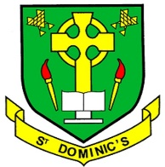
P1 – P7 Aladdin, October 2026 – a ParentPay is now available to make your payment of £2 per primary pupil. The School Fund will cover the remaining balance.

Annual Data Checks, Permissions & Policies Overdue
 | Thank you to those families who have completed these annual PKC checks, permissions and policies. If you have found this difficult to do and would like some help in person, please email or pop into the school office. If you are unsure what you have left to complete, please phone or email the school office.

St Fillan’s Parish News
 | St Fillan's RC Parish Crieff | Crieff | Facebook
 | Flyers

Please look out for a ParentPay email sent today ‘what’s on in Strathearn’, for flyers we have been asked to share. Disclaimer: we are simply sharing and by no means are responsible for or endorse any of the flyers shared.
What’s on Next Week
Wear PE KIT to school on your class PE day:
Tuesday: P1/2, P2/3, P3/4 & P7
Thursday: P1/2, P3/4, P5, P6 & P7
Friday: P2/3, P5 & P6

Monday 05:
Tuesday 06: Tuesday 6 October: Family meet the teacher, in classrooms @ 3:30 – 4:30pm (last entry 4:15pm). H&W with Mrs Ogg: P1/2, P7 & P3/4. Rosary Club with Mrs Dowell @ 1:30pm
Wednesday 07: Assembly am. Citizenship groups 2:15 -3pm
Thursday 08:
Friday 09: Last Day of Term - please note the last day of term is a full school day. H&W with Mrs Ogg: P5, P6 & P2/3. P5 & P2/3 to attend Mass at St Fillan’s Parish. Come Read With Me House Groups 2:45 – 3:15pm.
 | Term 2 Dates for Your Diary
Monday 26 October: ELC & School Resume
Friday 30 October: Aladdin Show @ 09:30am, Campus
Tuesday 10 November: Family Contact with class teacher, 1 of 2: 3:45 – 8:05pm in school hall.
Friday 6 November: Family Beetle Drive @ 6-8pm, in school hall.
Thursday 12 November: ELC & School closed for INSET2

Friday 13 November: ELC & School closed for INSET3
Thursday 19 November: Homework Focus Group Meeting @ 4:30pm, school hall.
Sunday 29 November: P7 hosting Catholic Education Week Mass @ 11am, St Fillan’s Parish.

Saturday 5 December: St Dominic’s Christmas Fair in School, 10:30am – 12:30pm
Thursday 10 December: St Dominic’s Christmas Concert @ 2pm, Campus
Wednesday 16 December: Tayside Christmas Lunch
Friday 18 December: Primary pupils attending Pantomime @ Perth Theatre
Monday 21 December: Christmas Party Disco – during school day.
Wednesday 23 December: End of Term Mass @ 09:30am, St Fillan’s Parish (all families welcome). ELC & School Close @ 12pm.
Christmas Holidays: Thursday 24 December – Wednesday 6 January 2027
Have a lovely weekend, Mrs E Hunter, Head Teacher

