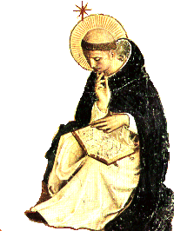

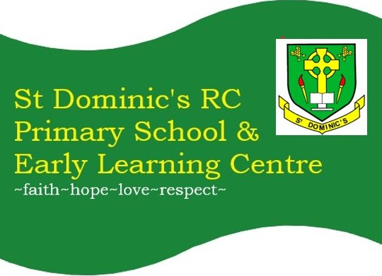
NEWSLETTER 25.09.26: 6
st-dominics@pkc.gov.uk

SCONTAINS:  - Message  - Placements  - Christmas  - Meet the Teacher  - Payments  - Reminders  - Flyers  - Next Week  - T1 Dates  PARENT COUNCIL (SCHOOL HALL):  Family Beetle Drive: 06/11/26 @ 6-8pm  T2 Meeting: 19/11/26 @ 5:30pm  Quiz Night: 05/02/26 @ Parish Hall  T3 Meeting: 25/02/27 @ 5:30pm  T4 Meeting: 03/06/27 @ 5:30pm  6  +  +3 | Dear Families,
 | Thank you to all the families who joined us for our Macmillan Coffee Morning. We are delighted to share that we raised £544.30 today. Well done to Primary 7 for organising such a successful and well-attended event and thank you to everyone who generously donated delicious home baking and cakes.
 | Student Placement
 | Thank you to our CHS pupils for choosing St Dominic’s for your work placement. We hope you have enjoyed your time and wish you well in your studies.
 | Christmas Card & Gift Orders
It is that time of year again where the children have been busy with their Christmas designs. Each pupil will bring home their artwork, as well as a blank form for another design if they wish.
Please return your chosen design to the school office by Friday 02 October. The online window for placing orders will close on Tuesday 03 November.
 | Family meet the Teacher: Tuesday 6 October, 3:30 -4:30pm
 | We warmly invite you to join us for our Meet the Teacher Open Afternoon on Tuesday 6 October. This will be a lovely opportunity to visit your child’s classroom, meet their teacher and discover some of the exciting learning experiences they enjoy at school. We look forward to welcoming you.
 | Parentpay Payments
P7 – Please ensure your instalments are up to date for Loch Insh. The next instalment is due on 30 September.
P1-P7 Pantomime, December 2026 – the next instalment is due on 30 October.
P1 – P7 Aladdin, October 2026 – a ParentPay is now available to make your payment of £2 per primary pupil. The School Fund will cover the remaining balance.
 | Annual Data Checks, Permissions & Policies Overdue
Thank you to those families who have completed these annual PKC checks, permissions and policies. We still have numerous families still to complete their annual data checks, permissions and policies.
If you would like some help in person, please email or pop into the school office. If you are unsure what you have left to complete, please phone or email the school office.
Unfortunately, we are unable to proceed with sharing of Sways until all of these permissions have been received.
 | St Fillan’s Parish News
 | St Fillan's RC Parish Crieff | Crieff | Facebook
 | Flyers
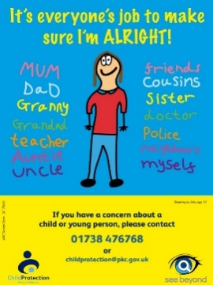
Please look out for a ParentPay email sent today ‘what’s on in Strathearn’, for flyers we have been asked to share. Disclaimer: we are simply sharing and by no means are responsible for or endorse any of the flyers shared.
What’s on Next Week
Wear PE KIT to school on your class PE day:
Tuesday: P1/2, P2/3, P3/4 & P7
Thursday: P1/2, P3/4, P5, P6 & P7
Friday: P2/3, P5 & P6

Monday 28: Tuesday 29: H&W with Mrs Ogg: P1/2, P7 & P3/4. Rosary Club with Mrs Dowell @ 1:30pm.
Wednesday 30: Assembly am. Citizenship groups 2:15 -3pm
Thursday 1: P6 Imagination & Story telling workshop with Fiona Lowry @ 09:30-10:30am
Friday 2: H&W with Mrs Ogg: P5, P6 & P2/3. NHS Flu Immunisations AM. P7 & P1/2 to attend Mass at St Fillan’s Parish.
 | Term 1 & 2 Dates for Your Diary
Tuesday 6 October: Family meet the teacher, in classrooms @ 3:30 – 4:30pm (last entry 4:15pm).
Friday 9 October @ 3:30pm: Last Day of Term Please note the last day of term is a full school day.

Monday 26 October: ELC & School Resume
Friday 30 October: Aladdin Show @ 09:30am, Campus
Tuesday 10 November: Family Contact with class teacher, 1 of 2: 3:45 – 8:05pm in school hall.
Thursday 12 November: ELC & School closed for INSET2
Friday 13 November: ELC & School closed for INSET3
Sunday 29 November: P7 hosting Catholic Education Week Mass @ 11am, St Fillan’s Parish.
Saturday 5 December: St Dominic’s Christmas Fair in School, 10:30am – 12:30pm
Thursday 10 December: St Dominic’s Christmas Concert @ 2pm, Campus
Wednesday 16 December: Tayside Christmas Lunch
Friday 18 December: Primary pupils attending Pantomime @ Perth Theatre
Monday 21 December: Christmas Party Disco – during school day.
Wednesday 23 December: End of Term Mass @ 09:30am, St Fillan’s Parish (all families welcome). ELC & School Close @ 12pm.
Christmas Holidays: Thursday 24 December – Wednesday 6 January 2027

Have a lovely weekend, Mrs E Hunter, Head Teacher

